# **Medical Plans – Cigna**

# Important Dates

• • •

**10:00 am EST and 3:30 pm EST** WebEx meetings on each of the following days

**Learn more and ask Questions!**

* 11/11
* 11/15
* 11/18
* 11/20

**WebEx call-in information and links have been sent via email. Both meetings on 11/11 and 11/20 will also take place in-person at the Windsor, CT office.**

**Please refer to the 2020 carrier Plan Summaries for more detail on our benefit plans. Documents can be found in ADP, under resources, Tools/References.**

**Please Contact us with Questions:** USBenefits@quest-global.com

2020 Open Enrollment November 11 – 24

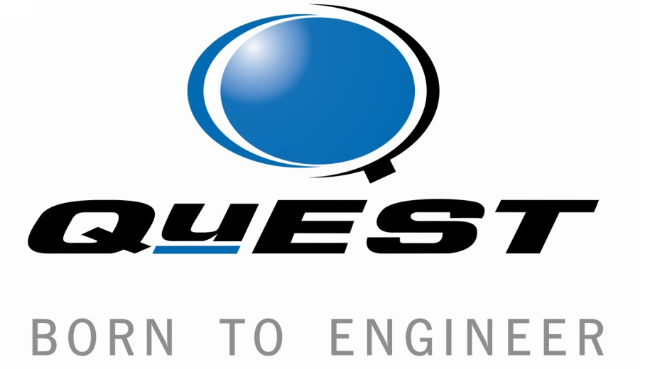

QuEST will continue to offer three Medical Plans in 2020 and are excited to announce Cigna as our new partner for Medical and Pharmacy coverage! We are decreasing the pharmacy generic/Tier 1 copay to $5. **If you are enrolled in Medical/Pharmacy, you will have a new ID card for 2020.**

* POS 1000 – 80
* POS 500 – 90 (closed to new entrants); previously called 300-90 Plan

***Annual Checklist***

* Enroll, change or cancel Medical, Dental, Vision & Voluntary plan coverage effective January 1, 2020
* You must re-enroll every year in: Health Care Flexible Spending Account, Dependent Care Flexible Spending Account, Health Savings Account & Vacation Buy Plan
* **Complete your online open enrollment through ADP**
* POS 3000 – 90 CDHP with HSA
* POS 5000 – 80 CDHP with HSA

**CDHP 3000-90 & 5000-80 Plans**

A Health Savings Account with Cigna/PNC Bank will be offered with this plan. QuEST will make contributions based on the tier of coverage you have elected. A Health Savings Account is a tax advantaged account that allows the funds to roll over and accumulate year to year. (Only Applicable to CDHP) Employees MUST activate their HSA account, while completing electronic enrollment via ADP. 2020 annual HSA contribution limit is $3,550 (individual coverage) & $7,100 (family coverage).

**POS Plans**

Although the premiums for these plans are higher, the plans have less liability for upfront out of pocket expense because the annual deductible is lower. Office visits, ER visits, and Rx prescriptions are not subject to deductible under

these plans and require only a copay. Note : Employees enrolled in 300 – 90 Plans will be auto enrolled in 500 – 90 Plan, unless they out or change their elections.

***Dental Plans – Aetna***

QuEST will continue offering the same dental plans (with plan enhancements to the PPO) as in past years:

* PPO
* DMO

Remember to plan carefully when making a decision. If you enroll in the DMO plan, you must designate a Primary Care Dentist. The DMO is only offered to certain states where there is an adequate provider network. Depending on the size of your family, it may make sense to set aside pre-tax dollars, in a Health Care Flexible Spending Account to pay for your dental expenses in either plan.

***Vision Plans – VSP***

One free exam is covered every 12 months. The plan provides an allowance of $200 for frames OR $170 for contacts, every 12 months. Enrollment is voluntary at 100% cost to you.

***Flexible Spending Accounts – Benefit Strategies***

**Health Care FSA**

You may set aside up to $2,700 of pre-tax dollars into an HCFSA to pay for qualified medical expenses. Expenses must be incurred before March 15th of the year following the plan year. You may submit your expenses until March 31st of the year following the plan year. This is a use-it-or-lose-it account.

**Dependent Care FSA**

You may set aside up to $5,000 in pre-tax dollars in a DCFSA to pay for qualified dependent care expenses. Expenses must be incurred before March 15th of the year following the plan year. You may submit your expenses until March 31st of the year following the plan year. This is a use-it-or-lose-it account.

# Regulatory Highlights

• • •

The Affordable Care Act requires health plans to provide proof to employees that healthcare coverage offered under our employee health plan meets the ACA’s minimum essential coverage & affordability requirements. As such, in early 2020, you will again receive Form 1095-C from ADP. Form 1095-C is used when filing your federal income tax return.

***FSA & HSA Taxation***

FSA and HSA contributions are tax-free as long as they are used for qualified expenses. Eligible expenses are defined by IRS under Code Section 213 (d). For detailed explanation and listing of eligible expenses or restrictions, please review the IRS publication at: [http://www.irs.gov/pub/irs- pdf/p502.pdf](http://www.irs.gov/pub/irs-%20pdf/p502.pdf)

If you are enrolled in HSA, you will be ineligible to enroll in Medical FSA and Vice Versa

***Basic Life, Short Term and Long Term Disability – The Hartford***

Enrollment into Basic Life; AD&D, STD and LTD plans is automatic and Company paid. No action is required on your end.

***Voluntary Plans***

Enrollment is voluntary at a 100% cost to you.

* Hyatt Legal
* Supplemental Life – The Hartford
* Buy-Up LTD – The Hartford
* Critical Illness – The Hartford
* Accident Insurance – The Hartford

For these voluntary benefits, existing coverage will roll over to 2020, unless action is taken to terminate or change coverage.

***Employee Assistance Program (EAP) – The Hartford***

Available to all benefit eligible employees. EAP offers support & resources for concerns around parenting problems, work stress, personal matters. These are applicable only to POS Plans.

***Other Programs***

We also have many free programs through our partnership with The Hartford, including:

* Identity Theft Protection
* Travel Assistance
* Beneficiary Assistance
* Will Preparation
* Estate Guidance
* Funeral Planning

View ADP for further information on each of these programs.

|  |  |  |
| --- | --- | --- |
|  | 2020 Open Enrollment Process |  |

***Vacation Buy Plan***

Employees may purchase up to 40 hours of vacation time by enrolling into Vacation buy plans ( in 8 hour Increment) Deductions are based on the hourly pay rate at the time of purchase and the amount of time purchased. The deductions come out of a pretax basis. Employees must use the company paid vacation and other time off before using Vacation buy hours. Remember, this is a Use-it-or-lose-it benefit. Please plan before you buy additional vacation time.

Login to [https://workforcenow.adp.com](https://workforcenow.adp.com/) and click on “Start Enrollment.”

If you do not take action, the following may apply:

* If you are currently enrolled in Medical, Dental, Vision or voluntary plans, your enrollment will roll over to the 2020 plan year and your payroll will be deducted according to enrollment
* Please check your Supplemental Life/AD&D election. If the Life amount did not match the AD&D amount in the past, we have updated it in ADP. Please review your costs for 2020 as it may differ from 2019.

**You MUST take action to enroll into Flexible Spending Account (Health Care & Dependent Care), Vacation Buy Plan and Health Savings Account. Your elections, will NOT roll over to 2020.**

**Last Day to Enroll – November 24, 2019**

***Pay Periods***

In 2020, there will be 26 pay cycles, of which 24 will include benefit deductions.

***Enroll or make changes before November 24, 2019 or you will be unable to do so.***

***2020 Holidays- Tentative***



***\* QuEST Oil and Gas Employee may be offered another day during the year.***